

Budgetary Management Subsystem

Detail Design Document

Data Design

**Project Code: BMS**

**Document Code: BMS-DD – v1.0**

**Hanoi, 28th Oct 2015**

Change History

*A – Add、M – Modify、D – Delete

|  |  |  |  |  |
| --- | --- | --- | --- | --- |
| Date | Change Item | A* M、D | Change Content | Version |
| 2015/10/28 | All | A | Create New | 1.0 |
|  |  |  |  |  |
|  |  |  |  |  |
|  |  |  |  |  |
|  |  |  |  |  |
|  |  |  |  |  |
|  |  |  |  |  |
|  |  |  |  |  |
|  |  |  |  |  |
|  |  |  |  |  |

**Signature page**

**Creator：** Name: Nguyen Ba Tu Date: 2015/10/28

Position: Developer

**Reviewer：** <Name> <Date>

<Position>

<Name, if it’s needed> <Date>

<Position>

**Approver：** <Name> <Date>

<Position>

table of contents

1 Introduction 3

1.1 Purpose 3

1.2 Definition、Acronyms and Abbreviation 3

1.3 References 3

1.4 Overview 3

2 Database 3

2.1 ER diagram 3

2.2 XXX Table 3

3 File Design 3

3.1.1 XXX File 3

4 Code design 3

4.1 <Customer Code> 3

5 Other Considerations 3

6 Appendix 3

6.1 Data Format Symbols 3

# Introduction

## Purpose

This document describes structure of database and the file structure of the system including internal file structure as well as interface file structure. Developer and tester will base on this design document to implement and unit test.

## Definitions、Acronyms and Abbreviations

| Abbreviation | Description | Note |
| --- | --- | --- |
| BMS | Budgetary Management System | Stands for System name |
| ERD | Entity Relationship Diagram |  |
| TLTH | Division Assistant | TLTH voucher is voucher that was combined from many voucher |
| TLTHCuc | Department Assistant | TLTHCuc Voucher is voucher that was combined from many TLTH voucher |

## References

|  |  |
| --- | --- |
| Document No. | Document Name |
| 1 | BMS_DetailDesign_DBSchema.xlsx |
|  |  |

## Overview

BMS project’s data design document includes:

* ER Diagram
* Database design
* File Design
* Other considerations

# Database

## ER diagram

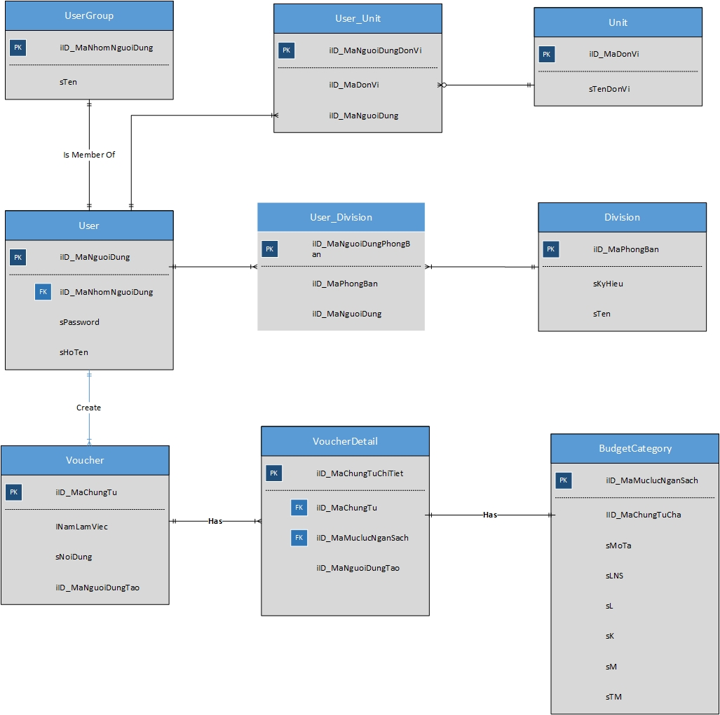

|  |  |  |
| --- | --- | --- |
| No | Table Name | Description |
| 1 | DT_ChungTu | Stores all manual budget estimation voucher |
| 2 | DT_ChungTuChiTiet | Detail information of each manual budget estimation voucher |
| 3 | DTBS_ChungTu | Stores all additional budget estimation voucher |
| 4 | DTBS_ChungTuChiTiet | Detail information of each additional budget estimation voucher |
| 5 | DTBS_ChungTu_TLTH | Stores all additional estimation TLTH voucher(first combined voucher) |
| 6 | DTBS_ChungTu_TLTHCuc | Stores all additional estimation TLTHCuc voucher(second combined voucher) |
| 7 | CP_CapPhat | Stores all allocation voucher |
| 8 | CP_CapPhatChiTiet | Detail information of each allocation voucher |
| 9 | QTA_ChungTu | Stores all settlement voucher |
| 10 | QTA_ChungTuChiTiet | Detail information of each settlement voucher |
| 11 | NS_MucLucNganSach | Contains all budget type category |
| 12 | NS_NguoiDung_DonVi | Contains all relationship between user and unit |
| 13 | NS_NguoiDung_PhongBan | Contains all relationship between user and division |
| 14 | NS_PhanHe | Lists all module name |
| 15 | NS_PhanHe_TrangThaiDuyet | Contains all voucher status of each module |
| 16 | NS_PhongBan | Contains all division |
| 17 |  |  |

## Tables Detail

*Refer File: BMS_DetailDesign_DBSchema.xlsx*

# File Design

<File list >

|  |  |  |  |
| --- | --- | --- | --- |
| No | File Name | File Type | Description |
|  | name of file | <Fixed length>  <CSV> |  |
|  |  |  |  |
|  |  |  |  |
|  |  |  |  |

### XXX File

**File format**

<Describe the file format with the sequential of field>

#### Field

<if this file is CSV File>

|  |  |  |  |
| --- | --- | --- | --- |
| No | Field Name | Format | Description |
|  |  | special format such as date “mm/dd/yy” |  |
|  |  |  |  |
|  |  |  |  |
|  |  |  |  |

<If this file is fixed length>

|  |  |  |  |  |  |
| --- | --- | --- | --- | --- | --- |
| No | File Name | Format | Start | End | Description |
|  |  |  |  |  |  |
|  |  |  |  |  |  |
|  |  |  |  |  |  |
|  |  |  |  |  |  |

# Code design

<Design the format of codes ex. Customer codes, product codes that are complicated and contains meanings. These codes are fields in database or files. >

<List of code>

|  |  |  |
| --- | --- | --- |
| No | Code | Description |
| 01 | Customer code | Code of customer in the system. |
|  |  |  |
|  |  |  |
|  |  |  |

## <Customer Code>

*<Customer code has the form of AAAMMYYYY000 which*

*AAA: 3 required characters stand for Province of customer such as HAN: Ha Noi, DAN: Da Nang, HCM: Ho Chi Minh City*

*MM: The month that customer registers; can be 01 to 12*

*YYYY: The year that customer registers; it is in 4 character form: ex. 2004*

*000 is the sequential number start from 0; each customer has one number: “000”; “001”*

*example of customer code: HAN121999001>*

# Other Considerations

[This section provides a description of other design elements that were considered as alternatives in selection process for the above database design, i.e. a brief explanation of advantages and disadvantages of the selected entity relationships and/or database implementation in comparison with others. It should be a clear answer to the question why the above data design is selected for this system, not the others.]

# Appendix

## Data Format Symbols

Use the following symbols in the data field and the format of the table of file

| Symbol | Description |
| --- | --- |
| # | Digit placeholder |
| . | Decimal placeholder |
| , | Thousands separator |
| : | Delimiter of time |
| / | Delimiting date |
| \ | The next character of this symbol it means that it is literal. In the mask, "#", "&", and it is also authorized to use the "A" and "?". This symbol is used in the masking purposes as literals. |
| > | It converts all characters to uppercase. |
| < | It converts all characters to lowercase. |
| A | Alphanumeric placeholder (mandatory). Example: a - z, A - Z or 0 - 9 |
| a | Alphanumeric placeholder (Optional input). |
| 9 | Digit placeholder (Optional input). Example: 0 - 9 |
| 0 | Digit placeholder (mandatory). Example: 0 - 9 |
| C | Character or space placeholder (Optional input). Valid values for this placeholder in the range of "32-126" and "128-255", the ANSI character. |
| & | Character placeholder (mandatory). Valid values for this placeholder in the range of "32-126" and "128-255", the ANSI character. |
| ? | Letter placeholder. Example: a - z or A - Z |
| Literal | All other symbols literal and displayed surrounded by double quotations as "" ABC "". |